

**COMP H2029 Web Applications**

Lecturer: Frances Murphy

Student Number: B00060572

Student: David Kelly

Course: BN104

Group: 3

CA: 2

Date: 5/5/2014

Contents

Folders & Files 3

Database SQL Scripts 4

Screenshots 7

Home 7

Catalog 7

Cart 8

Checkout 8

OrderCompleted 9

Display 9

Code 10

Cart 10

Checkout 13

Folders & Files

DVD/Customer/ about.php

cart.php

catalog.php

checkout.php

detailMovie.php

index.php

search.php

admin/ admin_about.php

admin_catalog.php

admin_delete.php

admin_home.php

admin_insert.php

admin_search.php

admin.php

css/ admin_style.css

style.css

images/ argo.jpg

batman.jpg

blade.jpg

fargo.jpg

rushmore.jpg

spiderman.jpg

titanic.jpg

topgun.jpg

valkyrie.jpg

include/ adminHeader.html

db_connect.php

footer.html

header.html

Database SQL Scripts

-- --------------------------------------------------------

--

-- Table structure for table `cart`

--

CREATE TABLE IF NOT EXISTS `cart` (

`movieID` int(250) NOT NULL,

`session_id` char(30) NOT NULL,

`title` varchar(20) NOT NULL,

`price` decimal(9,2) DEFAULT NULL,

`quantity` int(11) DEFAULT '1',

PRIMARY KEY (`movieID`)

) ENGINE=MyISAM DEFAULT CHARSET=latin1;

--

-- Dumping data for table `cart`

--

-- --------------------------------------------------------

--

-- Table structure for table `customer`

--

CREATE TABLE IF NOT EXISTS `customer` (

`customer_id` varchar(29) NOT NULL,

`first_name` char(30) NOT NULL,

`surname` char(30) NOT NULL,

`address` varchar(30) NOT NULL,

`delivery_address` varchar(30) NOT NULL,

PRIMARY KEY (`customer_id`)

) ENGINE=MyISAM DEFAULT CHARSET=latin1;

--

-- Dumping data for table `customer`

--

INSERT INTO `customer` (`customer_id`, `first_name`, `surname`, `address`, `delivery_address`) VALUES

('536114cf1b1d2', 'David', 'Kelly', '123 Fake St.', '123 Fake St');

-- --------------------------------------------------------

--

-- Table structure for table `orders`

--

CREATE TABLE IF NOT EXISTS `orders` (

`order_id` varchar(29) NOT NULL,

`customer_id` varchar(30) NOT NULL,

`session_id` char(30) NOT NULL,

`first_name` char(30) NOT NULL,

`surname` char(30) NOT NULL,

`address` varchar(30) NOT NULL,

`delivery_address` varchar(30) NOT NULL,

`title` varchar(20) NOT NULL,

`subtotal` decimal(9,2) DEFAULT NULL,

`credit_card` varchar(20) NOT NULL

) ENGINE=MyISAM DEFAULT CHARSET=latin1;

--

-- Dumping data for table `orders`

--

INSERT INTO `orders` (`order_id`, `customer_id`, `session_id`, `first_name`, `surname`, `address`, `delivery_address`, `title`, `subtotal`, `credit_card`) VALUES

('ORD536114cf1b1e0', '536114cf1b1d2', 'af99f5677830ecf59085cb4b86fcaa', 'David', 'Kelly', '123 Fake St.', '123 Fake St', '', 19.99, '1234567891012345');

-- --------------------------------------------------------

--

-- Table structure for table `product`

--

CREATE TABLE IF NOT EXISTS `product` (

`movieID` char(15) NOT NULL,

`title` varchar(100) NOT NULL,

`studio` varchar(20) NOT NULL,

`year` year(4) NOT NULL,

`price` decimal(9,2) DEFAULT NULL,

`image` varchar(20) DEFAULT NULL,

PRIMARY KEY (`movieID`)

) ENGINE=MyISAM DEFAULT CHARSET=latin1;

--

-- Dumping data for table `product`

--

INSERT INTO `product` (`movieID`, `title`, `studio`, `year`, `price`, `image`) VALUES

('1', 'Titanic', 'Fox', 1999, 14.99, 'titanic.jpg'),

('2', 'Spiderman', 'Paramount', 2005, 14.99, 'spiderman.jpg'),

('3', 'Rushmore', 'Fox', 2006, 14.99, 'rushmore.jpg'),

('4', 'Fargo', 'Paramount', 2001, 9.99, 'fargo.jpg'),

('5', 'Argo', 'Universal', 2013, 9.99, 'argo.jpg'),

('6', 'Batman', 'Lions Gate', 2006, 14.99, 'batman.jpg'),

('7', 'Valkyrie', 'Fox', 2005, 19.99, 'valkyrie.jpg'),

('8', 'Top Gun', 'Warner Brothers', 1989, 9.99, 'topgun.jpg'),

('9', 'Blade', 'Paramount', 1999, 9.99, 'blade.jpg');

-- --------------------------------------------------------

--

-- Table structure for table `users`

--

CREATE TABLE IF NOT EXISTS `users` (

`user_id` char(15) NOT NULL,

`username` varchar(30) NOT NULL,

`password` varchar(30) NOT NULL,

PRIMARY KEY (`user_id`)

) ENGINE=MyISAM DEFAULT CHARSET=latin1;

--

-- Dumping data for table `users`

--

INSERT INTO `users` (`user_id`, `username`, `password`) VALUES

('1', 'david', 'dave1'),

('2', 'frances', 'fran1');

Screenshots

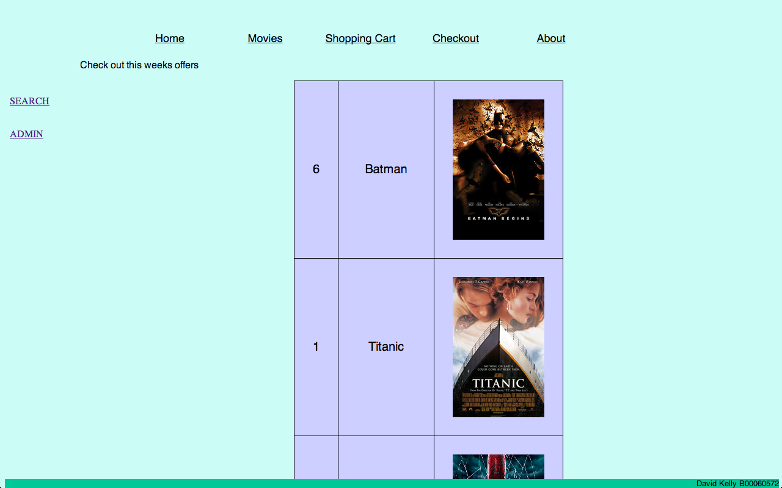

Home

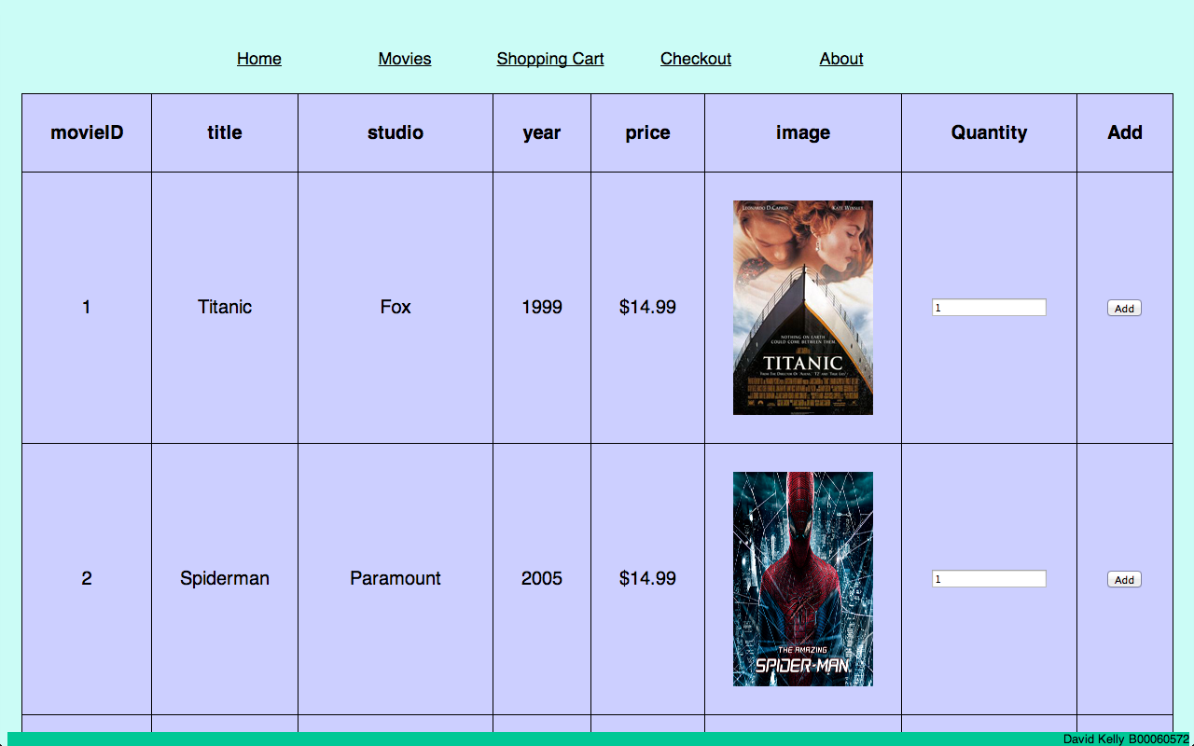

Catalog

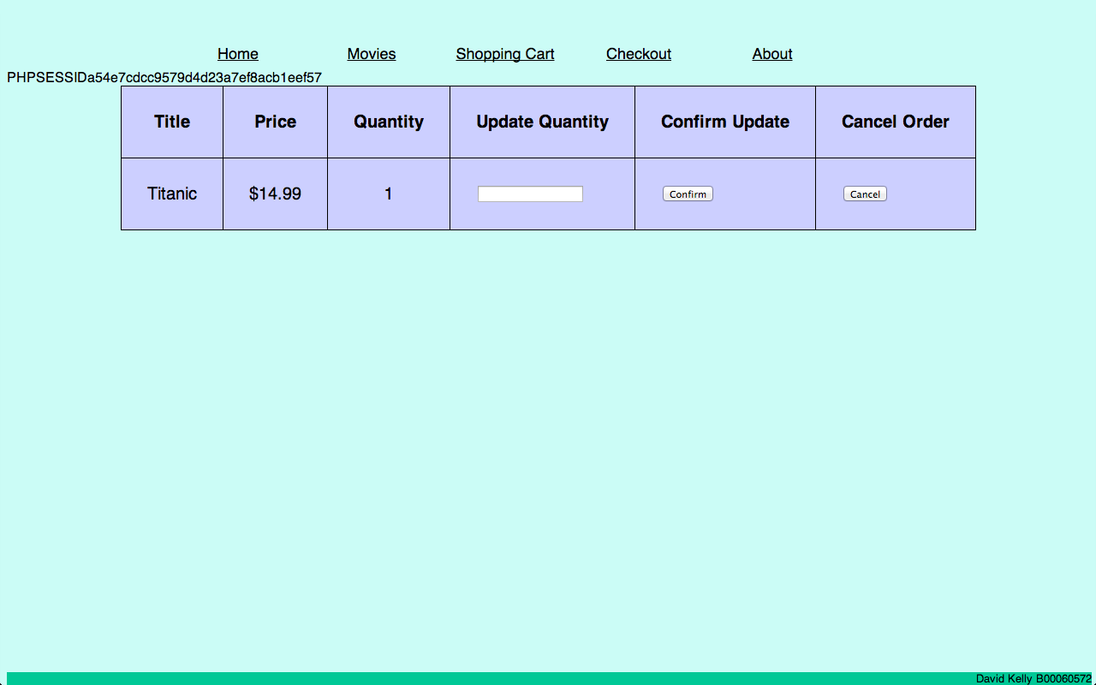

Cart

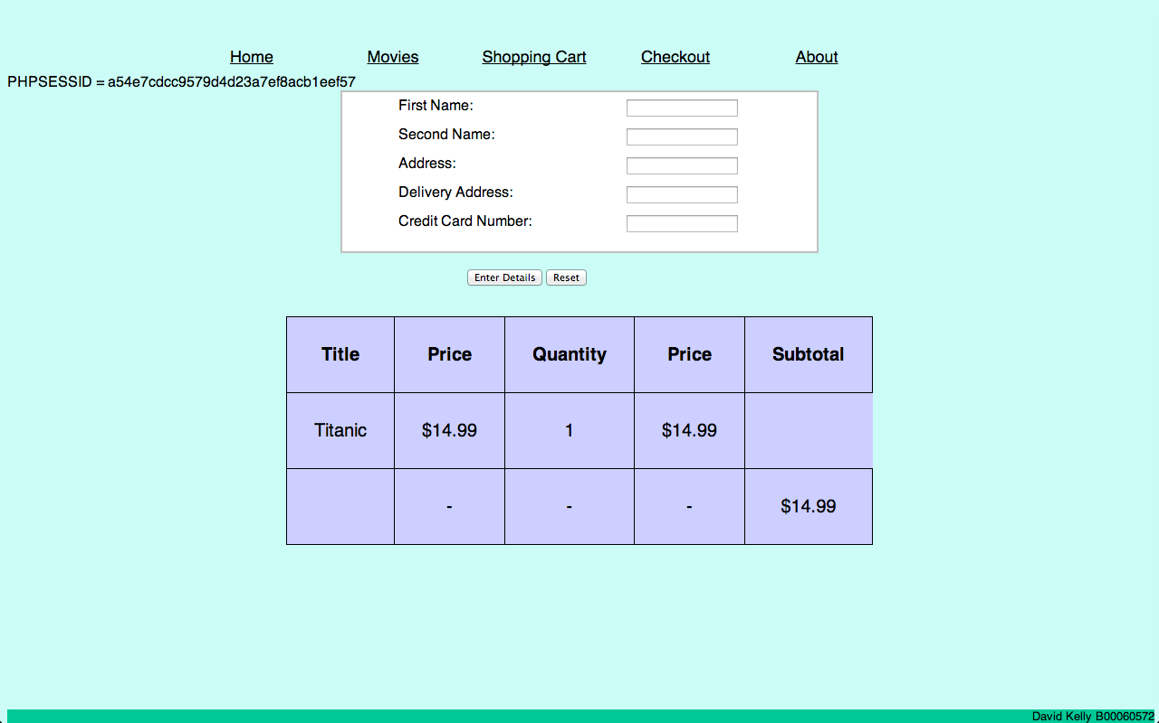

Checkout

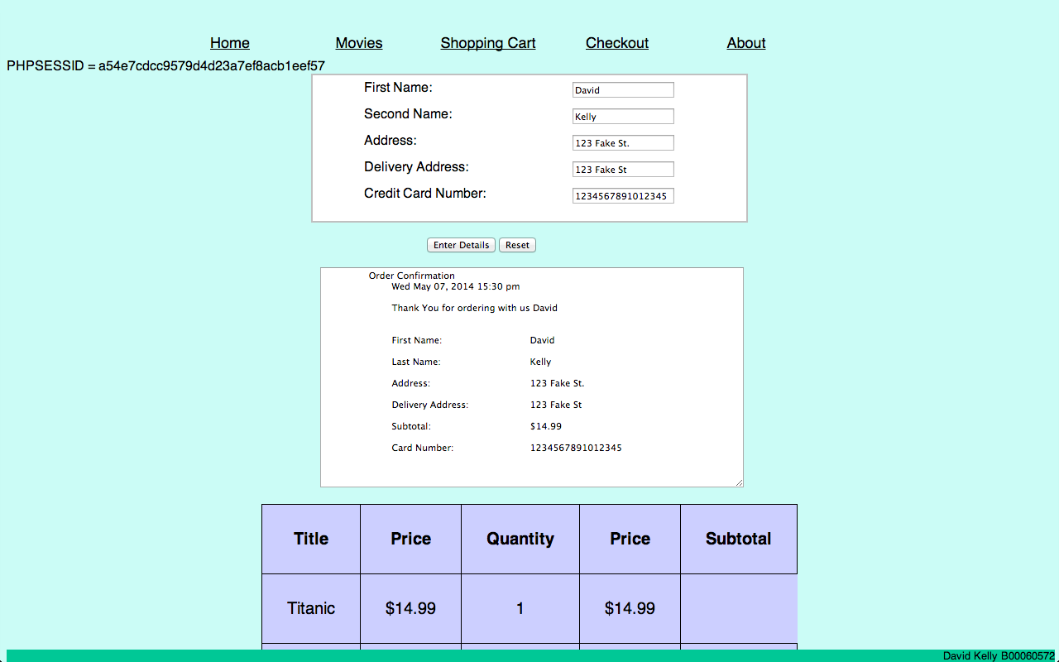

Order Completed

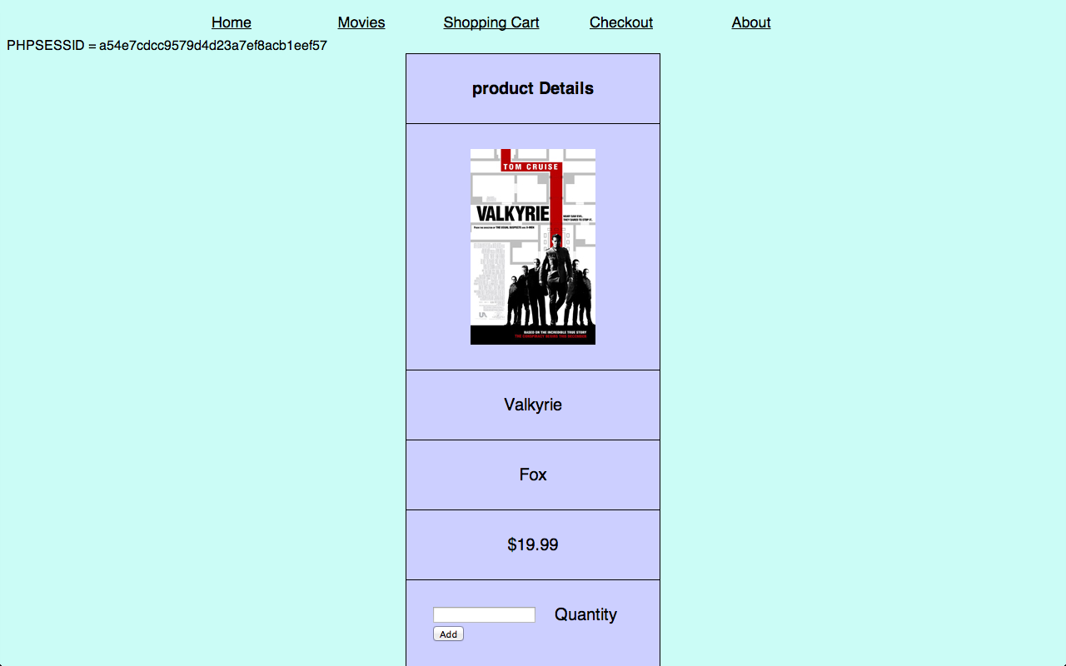

Display

Code

Cart.php

<?php

session_start();

require_once("include/db_connect.php");

?>

<html>

<head>

<title>Cart</title>

</head>

<body>

<?php

include ('include/header.html'); // Include the HTML footer.

?>

<br>

<?php

if (isset($_POST['button']))

{

update_table();

exit;

}

if (isset($_POST['cancel']))

{

cancel_order();

exit;

}

$db_link = db_connect("project");

$self = $_SERVER['PHP_SELF'];

$session = (int)session_id();

foreach($_REQUEST as $key=>$value)

echo("<tr><td>$key</td><td>$value</td></tr>");

$fields = mysql_list_fields("project", "cart");

$num_columns = mysql_num_fields($fields);

$query = "SELECT * FROM cart WHERE session_id = ".$session.";";

$result = mysql_query($query) or die("SQL failed");

echo '<table border="1">';

echo "<tr>";

echo "<th> Title </th>";

echo "<th> Price </th>";

echo "<th> Quantity </th>";

echo "<th> Update Quantity </th>";

echo "<th> Confirm Update </th>";

echo "<th> Cancel Order </th>";

echo "</tr>";

while ($row = mysql_fetch_assoc($result))

{

echo "<tr>";

echo "<td>".$row['title']. "</td>";

echo "<td>$".$row['price']."</td>";

echo "<td>".$row['quantity']."</td>";

$title=$row['title'];

$price=$row['price'];

$quantity = $row['quantity'];

$movieID = $row['movieID'];

?>

<form action="" method="post">

<input type="hidden" name="price" value="<?php echo $price ?>">

<td><input type="text" name="quantity"</td>

<td><input type="submit" name="button" value="Confirm"></td>

<td><input type="submit" name="cancel" value="Cancel"></td>

<input type="hidden" name="movieID" value="<?php echo $movieID ?>">

<input type="hidden" name="title" value="<?php echo $title ?>">

</form>

</body>

</html>

<?php

echo "</tr>";

}

mysql_free_result($result);

mysql_close($db_link);

function cancel_order()

{

$db_link = db_connect("project");

$sessionID = session_id();

$movieID = $_REQUEST['movieID'];

$price = $_REQUEST['price'];

$quantity =$_REQUEST['quantity'];

$title =$_REQUEST['title'];

$sql2 = "DELETE from cart WHERE title = '$title'";

$result2 = mysql_query($sql2);

if(!$result2) die('Could not insert data because ' . mysql_error());

mysql_close($db_link);

$page = $_SERVER['PHP_SELF'];

$sec = ".01";

//header("Refresh: $sec;$page");

}

function update_table()

{

$db_link = db_connect("project");

$sessionID = session_id();

$movieID = $_REQUEST['movieID'];

$price = $_REQUEST['price'];

$quantity =$_REQUEST['quantity'];

$title =$_REQUEST['title'];

if($quantity !=0)

{

$sql2 = "UPDATE cart SET quantity = '$quantity' WHERE title = '$title'";

$result2 = mysql_query($sql2);

if(!$result2) die('Could not insert data because ' . mysql_error());

}

mysql_close($db_link);

$page = $_SERVER['PHP_SELF'];

$sec = ".01";

//header("Refresh: $sec;$page");

}

?>

<?php

include ('include/footer.html'); // Include the HTML footer.

?>

Checkout

<?php

session_start();

require_once("include/db_connect.php");

?>

<html>

<head>

<title>Checkout</title>

</head>

<body>

<?php

include ('include/header.html'); // Include the HTML footer.

?>

<br>

PHPSESSID = <?php echo session_id(); ?>

<?php

$db_link = db_connect("project");

$self = $_SERVER['PHP_SELF'];

$first_name = isset($_REQUEST['firstname']) ? $_REQUEST['firstname'] : '';

$last_name = isset($_REQUEST['surname']) ? $_REQUEST['surname'] : '';

$address = isset($_REQUEST['address']) ? $_REQUEST['address'] : '';

$delivery = isset($_REQUEST['delivery']) ? $_REQUEST['delivery'] : '';

$credit_card = isset($_REQUEST['card']) ? $_REQUEST['card'] : '';

$session = (int)session_id();

$total=0;

$final_total=0;

$fields = mysql_list_fields("project", "cart");

$num_columns = mysql_num_fields($fields);

$query = "SELECT * FROM cart WHERE session_id = ".$session.";";

$result = mysql_query($query) or die("SQL failed");

echo '<table>';

echo "<tr>";

echo "<th> Title </th>";

echo "<th> Price </th>";

echo "<th> Quantity </th>";

echo "<th> Price </th>";

echo "<th> Subtotal </th>";

echo "</tr>";

while ($row = mysql_fetch_assoc($result))

{

echo "<tr>";

echo "<td>".$row['title']. "</td>";

echo "<td>$".$row['price']."</td>";

echo "<td>".$row['quantity']."</td>";

$quantity = $row['quantity'];

$title=$row['title'];

$price=$row['price'];

$total = $quantity*$price;

echo "<td>$$total</td>";

$final_total += $total;

$movieID = $row['movieID'];

?>

<form action="" method="post">

<input type="hidden" name="price" value="<?php echo $price ?>">

<input type="hidden" name="movieID" value="<?php echo $movieID ?>">

<input type="hidden" name="subtotal" value="<?php echo $final_total?> ">

<input type="hidden" name="title" value="<?php echo $title ?>">

<br>

<head>

<link rel="stylesheet" type="text/css" href="style.css">

</head>

<fieldset>

<label>First Name:</label><input type ="text" value="<?php echo $first_name?>" name = "firstname"/>

<label>Second Name: </label><input type = "text" value="<?php echo $last_name?>" name = "surname"/>

<label>Address: </label><input type = "text" value="<?php echo $address?>" name = "address"/>

<label>Delivery Address: </label><input type = "text" value="<?php echo $delivery?>" name = "delivery"/>

<label>Credit Card Number: </label><input type = "text" value="<?php echo $credit_card?>" name = "card"/>

<input type="hidden" name="subtotal" value="<?php echo $final_total?> ">

</fieldset>

<div id = "buttons">

<input type = "submit" name = "button"value = "Enter Details">

<input type = "reset" value = "Reset"></p>

</div>

</form>

<br>

<br>

</body>

</html>

<?php

echo "</tr>";

}

echo "<th>";

echo "<td>-</td>";

echo "<td>-</td>";

echo "<td>-</td>";

echo "<td>$$final_total</td>";

echo "</th>";

mysql_free_result($result);

mysql_close($db_link);

?>

<?php

if (isset($_REQUEST['button']))

{

process_form();

}

else

{

display_form_page('');

}

?>

<?php

function display_form_page($error)

{

if ($error)

{

echo "<p>$error</p>\n";

}

}

?>

<?php

function process_form()

{

$error = validate_form();

if ($error)

{

display_form_page($error);

}

else

{

$db_link = db_connect("project");

$sessionID = session_id();

$first_name = $_REQUEST['firstname'];

$surname = $_REQUEST['surname'];

$address = $_REQUEST['address'];

$delivery = $_REQUEST['delivery'];

$total = $_REQUEST['subtotal'];

$credit_card = $_REQUEST['card'];

$customer_id = uniqid();

$order_id = uniqid("ORD");

$sql2= "DELETE from cart WHERE session_id = '$sessionID' ";

$result2 = mysql_query($sql2);

$sql2 = "INSERT INTO customer(customer_id,first_name,surname,address,delivery_address)

VALUES('$customer_id','$first_name','$surname','$address','$delivery')";

$result2 = mysql_query($sql2);

$sql2 = "INSERT INTO orders(order_id,customer_id,session_id,first_name,surname,address,delivery_address,subtotal,credit_card)

VALUES('$order_id','$customer_id','$sessionID','$first_name','$surname','$address','$delivery','$total','$credit_card')";

$result2 = mysql_query($sql2);

if(!$result2) die('Could not insert data' . mysql_error());

display_output_page();

mysql_close($db_link);

}

}

?>

<?php

function validate_form()

{

$first_name = trim($_REQUEST['firstname']);

$last_name = trim($_REQUEST['surname']);

$total = isset($_REQUEST['subtotal']) ? $_REQUEST['subtotal'] : '';

$address = isset($_REQUEST['address']) ? $_REQUEST['address'] : '';

$delivery = isset($_REQUEST['delivery']) ? $_REQUEST['delivery'] : '';

$credit_card = isset($_REQUEST['card']) ? $_REQUEST['card'] : '';

$error = '';

$reg_exp = '/^[a-zA-Z]+$/';

$reg_exp_surname = '/^[a-zA-Z]+$/';

$credit_exp = '/^[0-9]{16}$/';

$count =0;

if (! preg_match($reg_exp, $first_name))

{

$count++;

$error .= "<span class=\"error\"> $count First Name is invalid (letters, hyphens, ', only)</span><br>";

}

if (! preg_match($reg_exp_surname, $last_name))

{

$count++;

$error .= "<span class=\"error\">$count Last name is invalid (letters, hyphens, ', only)</span><br>";

}

if (strlen($delivery) == 0)

{

$count++;

$error .= "<span class=\"error\">$count Delivery Address is invalid (Invalid Address)</span><br>";

}

if (strlen($address) == 0)

{

$count++;

$error .= "<span class=\"error\">$count Address is invalid (Invalid Address)</span><br>";

}

if (! preg_match($credit_exp, $credit_card))

{

$count++;

$error .="<span class=\"error\">$count Enter Card Details correctly</span><br>";

}

return $error;

}

?>

<?php

function display_output_page()

{

$first_name = trim($_REQUEST['firstname']);

$last_name = trim($_REQUEST['surname']);

$delivery = isset($_REQUEST['delivery']) ? $_REQUEST['delivery'] : '';

$address = isset($_REQUEST['address']) ? $_REQUEST['address'] : '';

$self = $_SERVER['PHP_SELF'];

$total = isset($_REQUEST['subtotal']) ? $_REQUEST['subtotal'] : '';

$credit_card = isset($_REQUEST['card']) ? $_REQUEST['card'] : '';

?>

<form action="MAILTO:<?php echo $email;?>" method="post" enctype="text/plain">

<html>

<textarea name="output" cols="70" rows="20" readonly>

Order Confirmation

<?php echo date("D M d, Y G:i a\n\n"); ?>

<?php echo "Thank You for ordering with us $first_name \n\n\n" ?>

<?php echo "First Name:\t\t\t\t$first_name\n\n" ?>

<?php echo "Last Name:\t\t\t\t$last_name\n\n" ?>

<?php echo "Address:\t\t\t\t\t$address\n\n" ?>

<?php echo "Delivery Address:\t\t\t$delivery\n\n" ?>

<?php echo "Subtotal:\t\t\t\t\t$$total\n\n" ?>

<?php echo "Card Number:\t\t\t\t$credit_card\n\n" ?>

</textarea>

<?php

?>

</body>

<br>

</html>

<?php

}

?>

<?php

include ('Include/footer.html'); // Include the HTML footer.

?>